Week of : September 21, 2020 | Grade Level: Kindergarten
PYP Unit and Central Idea: Who We Are- Roles and responsibilities help us make connections.
Prioritized Standards Addressed This Week:
Math MGSEK.G.1 Describe objects in the environment using names of shapes, and describe the relative positions of these objects using terms such as above, below, beside, in front of, behind, and next to. MGSEK.G. 4 Analyze and compare two- and three-dimensional shapes, in different sizes and orientations, using informal language to describe their similarities, differences, parts (e.g., number of sides and vertices/“corners”) and other attributes (e.g., having sides of equal length).
Reading/ ELA ELAGSEKRL10: ELAGSEKRF3: Know and apply grade-level phonics and word analysis skills in decoding words. ELAGSEKRL1: With prompting and support, ask and answer questions about key details in a text

Science/ Social Studies SSKCG1 The student will demonstrate an understanding of good citizenship. SSKE1 Describe the work that people do such as: police officer, fire fighter, soldier, mail carrier, farmer, doctor, teacher, etc.

Asterisk & Highlighted items will be graded
Lessons Highlighted in blue will be Synchronous Lessons (Live in Teams)
Synchronous – Live Asynchronous – Not live

Weekly sight words: Weekly word family:
-on -am (Sam, ram, bam, ham, yam, etc.)
-so
-we
 | MONDAY | TUESDAY | WEDNESDAY | THURSDAY | FRIDAY

Student Login/  Morning Meeting (SEL)  8:15 a.m. | Focus Lessons  Synchronous- Share Screen  Heards Ferry Live  Morning Meeting | Focus Lessons  Synchronous- Share Screen  Heards Ferry Live  Morning Meeting | Focus Lessons  Synchronous- Share Screen  Heards Ferry Live  Morning Meeting | Focus Lessons  Synchronous- Share Screen  Heards Ferry Live  Morning Meeting | Focus Lessons  Synchronous- Share Screen  Heards Ferry Live  Morning Meeting  Announce student of the week for next week
Math  8:30 a.m. | Synchronous- Share Screen | Synchronous- Share Screen | Synchronous- Share Screen | Synchronous- Share Screen | Synchronous- Share Screen
 | Student Independent Practice  In Seesaw, find the activity below. Watch the instructional video and complete the assignment.  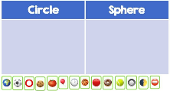 | Student Independent Practice  In Seesaw, find the activity below. Watch the instructional video and complete the assignment. | Student Independent Practice  In Seesaw, find the activity below. Watch the instructional video and complete the assignment.  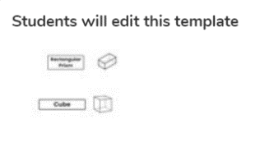 | Student Independent Practice  In Seesaw, find the activity below. Watch the instructional video and complete the assignment.  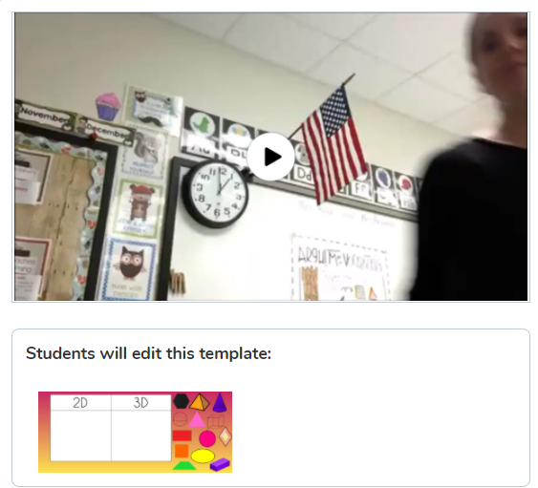 | Student Independent Practice  Complete the 3D Shape formative.  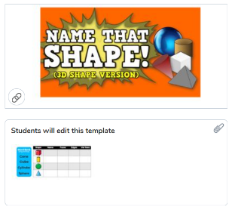  Students should complete the formative on their own, without prompting or assistance. You may help with reading the instructions or using technology.
Specials  9:10am | Art with Rizzo  Specials will now be conducted in Teams instead of Seesaw. When you join your specials team, find and click on the channel with our day and class name on it.  If you have any assignments to turn in, you will continue to submit them via Seesaw. | No specials day- Go Noodle, Iready reading and/or math, catch up on/begin independent practice, EPIC books, etc. | Music with Mrs. LeSaicherre  Specials will now be conducted in Teams instead of Seesaw. When you join your specials team, find and click on the channel with our day and class name on it.  If you have any assignments to turn in, you will continue to submit them via Seesaw. | PE with Coach K  Specials will now be conducted in Teams instead of Seesaw. When you join your specials team, find and click on the channel with our day and class name on it.  If you have any assignments to turn in, you will continue to submit them via Seesaw. | PE with Coach K  Specials will now be conducted in Teams instead of Seesaw. When you join your specials team, find and click on the channel with our day and class name on it.  If you have any assignments to turn in, you will continue to submit them via Seesaw.
Reading/ELA  11:15 a.m. | Synchronous- Share Screen | Synchronous- Share Screen | Synchronous- Share Screen | Synchronous- Share Screen | Synchronous- Share Screen
 | Student Independent Practice  Reading  Watch the “Connecting Words” Instructional Video on Seesaw.  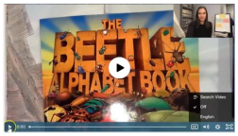  Listen to the old favorite storybook read aloud, “The Three Little Pigs” on Seesaw.  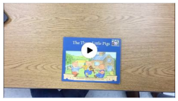  Phonics  Letter T  Watch the video lesson on the letter T. Then, drag the pictures into the correct column. 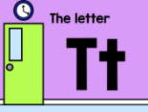 | Student Independent Practice  Reading  Watch the “Readers Use Exact Character Words” instructional video and complete the activity on Seesaw.  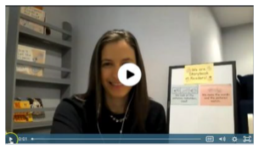  Phonics  Letter T  Watch the video lesson on the letter T. Then, use the drawing tool to circle the pictures that begin with the letter T.  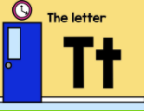 | Student Independent Practice  Student Independent Practice  Writing  Write another page in your teaching book and take a picture for your teacher.  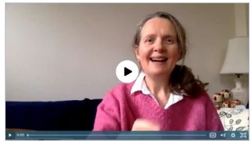  Phonics  Letter I  Watch the video lesson on the letter I. Then, drag the pictures to sort the beginning sounds: long I and short I.  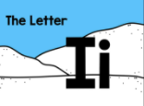 | Student Independent Practice  Writing  Keep working on writing teaching books. You may want to start a new book that you plan out, or you can finish a book that you already started.  Phonics  Letter I  Watch the video lesson. Then, listen to the beginning sound in each picture. Label each picture with “short I" or “long I”  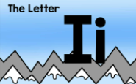 | Student Independent Practice  Phonics  Blending board  Watch the video lesson on Seesaw. Then, drag the vowels to complete the words. After, use the recording tool to read the word to your teacher.
Social Studies /Science  11:45 a.m. | Focused Lesson  No synchronous component Please watch the video on Seesaw and complete the assignment | Focused Lesson  No synchronous component Please watch the video on Seesaw and complete the assignment | Focused Lesson  No synchronous component Please watch the video on Seesaw and complete the assignment | Focused Lesson  No synchronous component Please watch the video on Seesaw and complete the assignment | Focused Lesson  No synchronous component Please watch the video on Seesaw and complete the assignment
 | Student Independent Practice  On Seesaw, watch the read aloud of “Whose Tools are These?”  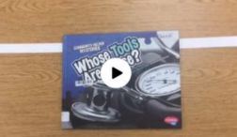  On a separate sheet of paper, write your first clue about the community helper you chose. You don’t need to submit anything today. You will submit all your clues on Thursday. | Student Independent Practice  On Seesaw, watch the read aloud of, “Whose Hands are These?”  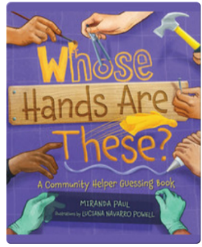  On a separate sheet of paper, write your second clue about the community helper you chose. You don’t need to submit anything today. You will submit all your clues on Thursday. | Student Independent Practice  On Seesaw, watch the read aloud of, “Whose Equipment is This?”  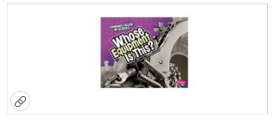  On a separate sheet of paper, write your third clue about the community helper you chose. You don’t need to submit anything today. You will submit all your clues on Thursday. | Student Independent Practice  On Seesaw,,watch the read aloud of, “Whose Gear is This?”  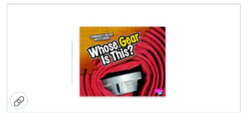  Submit your 3 community helper clues to Seesaw! | Student Independent Practice  On Seesaw, listen to the read aloud of “Say Something!” by Peter H Reynolds. Then, use the voice tool, drawing tool, or typing tool to “Say Something!”  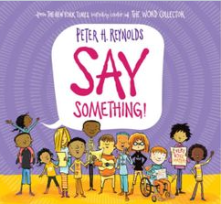
Independent Work Time  12:00-12:45 | Finish any Seesaw work  Iready math | Finish any Seesaw work  Iready reading | Finish any Seesaw work  Iready math | Finish any Seesaw work  Iready reading | Finish any Seesaw work  Iready math
Due Dates | All Independent practice activities will be due Friday October 9th. | All Independent practice activities will be due Friday October 9th. | All Independent practice activities will be due Friday October 9th. | All Independent practice activities will be due Friday October 9th. | All Independent practice activities will be due Friday October 9th.

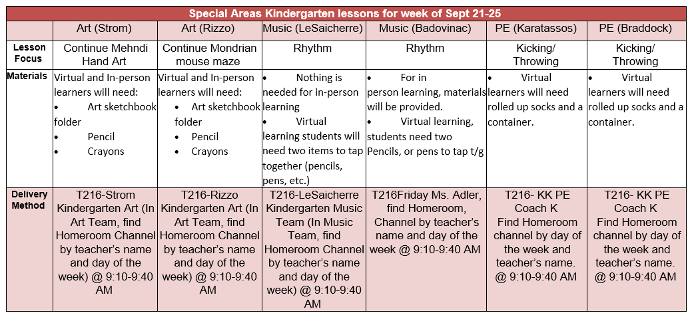
In Person:

Iready math and reading diagnostic
BAS Reading assessments
Read Alouds
Book Shopping
Shape Bingo
2d/3d Shape collages from magazines
Writing Piece-new topic
Review 2d shapes- 2d shape pictures using pattern blocks (In folder)
Making words- might want to have students bring their phonics letters in their resource folders

