Dear Parents,
As our fifth IB unit, “Sharing the Planet,” comes to an end we will be having students upcycle items to make new products. You will need recyclable materials for this project. Below is a list of suggested items that you can use.
- Bottle Caps
- Soda Can Tabs
- Old Crayons
- Toilet Paper/Paper Towel Rolls
- Six Pack Plastic Can Holders
- Empty Soup Cans
- Silverware
- Shoelaces
- Computer Keys
- Gum Wrappers
Keep in mind these are only examples and you can use whatever recyclable items you have around the house. Remember that the purpose of this assignment is to reuse these materials to create something new that can be used. Feel free to decorate however you would like. When students complete this, they can upload a photo/video to seesaw, send a photo/video to their teacher’s email, or turn it in when we return to school.

Thanks!
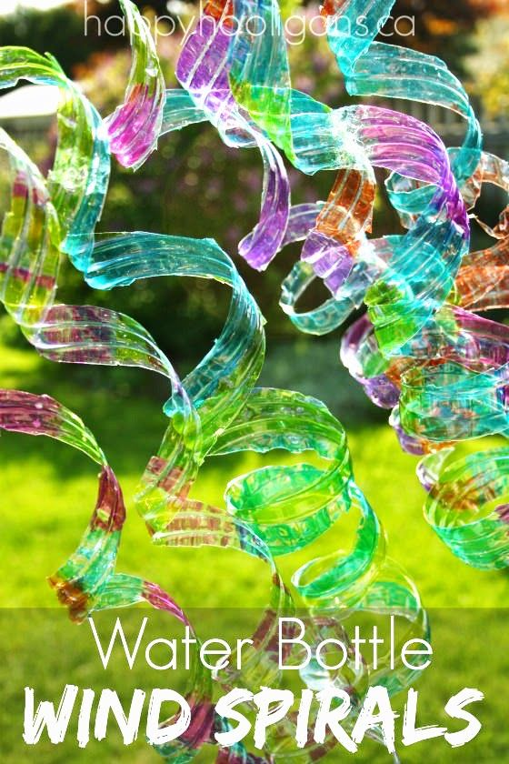
The Kindergarten Team
