 | Monday, March 23rd | Tuesday, March 24th | Wednesday, March 25th | Thursday, March 26th | Friday, March 27th
Math | Addition-Drawing a Picture Strategy  Please watch the “Addition Using Pictures” instructional video. This will be an attachment in your email.  Students will draw a picture for each addend below the equation and count all the pictures to find the sum.  This will be an attachment in your email.  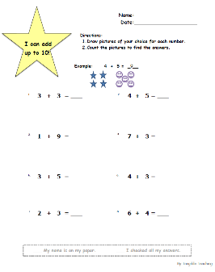 | Addition- Drawing a  picture strategy  Please watch the “Super Adler “instructional video. This will be an attachment in your email.  Sign into SeeSaw using your Classlink login or QR code. Go to the activities tab and find the assignment below.  Have students draw a picture below each addend below the equation and count all the pictures to find the sum.  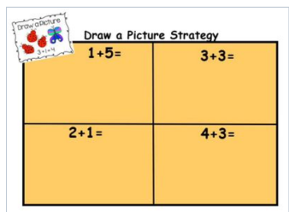 | Addition- Using objects strategy  Please watch the “Adding to the Tune of Happy” instructional video. This will be an attachment in your email.  You can use objects from around the house for this activity. Place the corresponding number of objects in each box for each addend. Count all of the objects to find the sum.  This will be an attachment in your email.  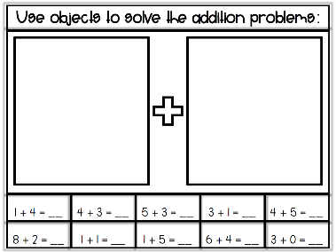 | Addition- Using objects strategy  Please watch the “ Super Adler” instructional video. This will be an attachment in your email.  Sign into SeeSaw using your Classlink login or QR code. Go to the activities tab and find the assignment below.  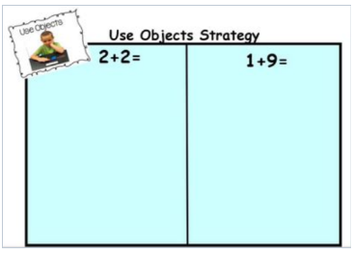 | Friends of Ten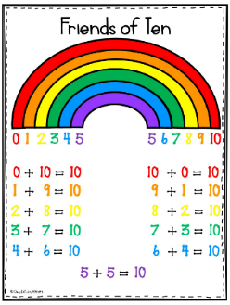  This anchor chart will be an attachment in your email. Use this to help students remember all the combinations that make 10.  Please watch the brain pop video :  https://jr.brainpop.com/math/additionandsubtraction/makingten/  Sign into SeeSaw using your Classlink login or QR code. Go to the activities tab and find the assignment below  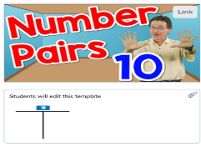  .
Reading/Phonics | Reading:  Authors write books. Illustrators draw the pictures for the books. These two people work together to help you understand a book. Choose a book to read or have someone read it to you.  ▪ Who is the author?  ▪ Who is the illustrator?  ▪ Read (or have someone read the book to you). As you are reading, look at the pictures.  ▪ Talk about what you see in the picture.  ▪ Then, find one thing that you notice in the picture that was not stated in the book.  ▪ Write this on a paper and post to Seesaw.  Phonics:  Complete the Phonics activity in Seesaw. Drag each picture to the correct digraph  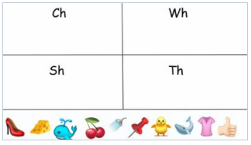 | Reading:  When we read a fiction book, we can identify the characters in the book. Choose a picture book. Read the book or have someone read it to you. Then do the following:  ▪ Identify the characters. ▪ Draw a picture of the characters in the book.  ▪ Label the characters.  ▪ How you would describe the characters?  Post to Seesaw when finished.  Phonics:  Complete the Phonics activity in Seesaw. Use the drawing tool to underline or circle the words that have a digraph. Then use the microphone tool to record yourself reading the words you underlined.  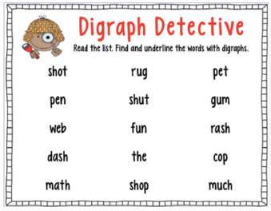 | Reading:  Practice your Sight Words!  Here are some fun ideas to work on your “snap” words!  - Rainbow  - Chalk  - Shaving Cream  - Magnet Letters  Challenge yourself! Try using the words in sentences.  honics:  Final Consonant Blends  -nd, -mp, -lt, -sk, -ft, -nk  Watch the video below:  https://www.youtube.com/watch?v=tgdX20eSisw&t=1s  Say these words aloud and have your child see if they can hear what two letters make the final sound at the end of the word:  Band, belt, gift, soft, felt, stand, whisk, champ, sand, drink, wink, desk | Reading:  Select a book from your home or library to read with a partner. Talk about the book with your partner using the questions below:  - What is your opinion of the book?  - What was your favorite part?  - Do you have a least favorite part?  - Would you want to read the book again?  Phonics:  Final Consonant Blends  Watch the video below:  https://www.youtube.com/watch?v=k-1rmuOxGE8&t=1s  Using a sheet of paper or a whiteboard, have your student write the final consonant blend they hear at the end of the words in the See It. Write It. Interactive Powerpoint attached to your email. (they do not need to write the whole word, only the final blend) For example: if the image shows the word “insect” your child will write “ct”.  Today’s words will be:  Insect, earth, ant, curl, reflect, bulb, milk, shark, salt, cold, act, pearl, point, bookshelf, belt, dust, desk  *Through slide #38  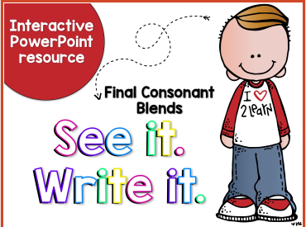 | Reading:  Reading:  Scratch Art Sight Words: Please see assigned activities in Seesaw. Click the Scratch Art Sight words activity and complete using the word lists provided.  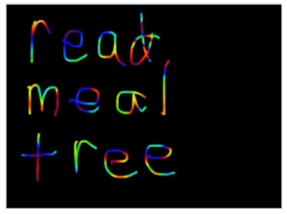  honics:  Using the same See It. Write It. Interactive PowerPoint from yesterday, have your student continue with the second half of the words  Today’s words in the PowerPoint:  Vest, text, scarf, wasp, card, hand, gift, tent, jump ,wind, stamp, subtract, stink, craft, wink, bird, mask, erupt.  *these words start at slide #40  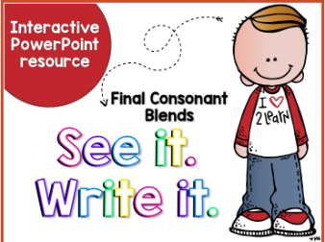
Writing | What is your favorite food? Write a sentence about it and give three reasons why it is so good.  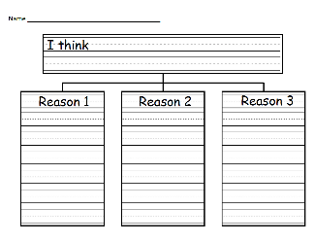 | Write a letter to Chef Reggie or your parents telling them to make your favorite food more often. Use the reasons you gave yesterday when to write your letters. Then, use your editing checklist to make it easy to read.  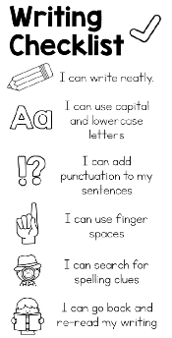 | Which season do you think is the best? Write a sentence about it and give three reasons why it is so good.  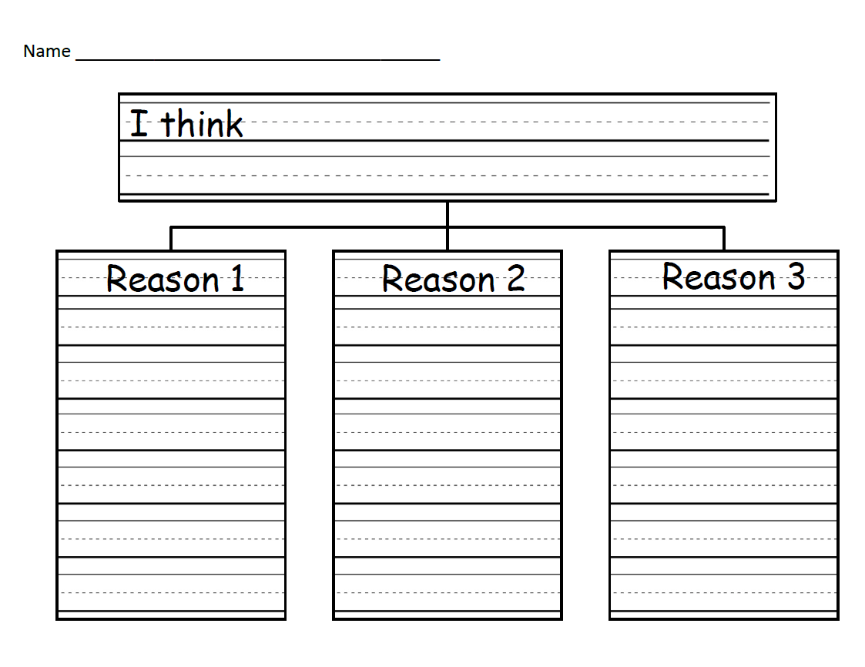 | Make a sign or poster about you’re your favorite season. Make sure to include all the reasons that you came up with yesterday. Use your writing checklist to make sure that your poster is easy to read and then add pictures and colors to grab reader’s attention!
Science | Complete the “Upcycling Project” using the newsletter found in your email attachments. This project will be ongoing for the entire week.  Compile a list of ideas of what your child may want to create and have your child draw what they what their project to look like .  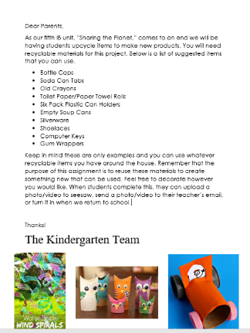 | complete the “Upcycling Project” using the newsletter found in your email attachments. This project will be ongoing for the entire week.  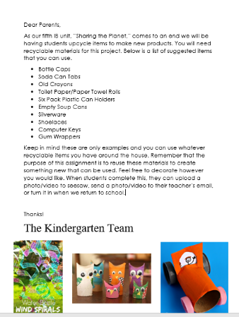 | Complete the “Upcycling Project” using the newsletter found in your email attachments. This project will be ongoing for the entire week.  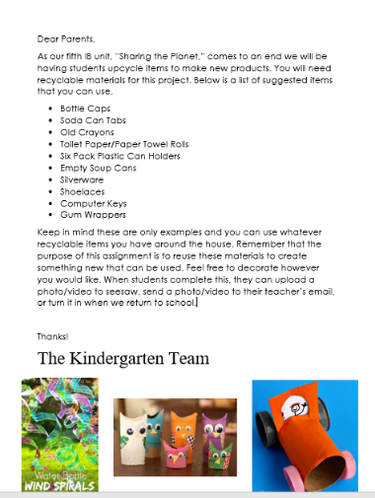 | Complete the “Upcycling Project” using the newsletter found in your email attachments. This project will be ongoing for the entire week.  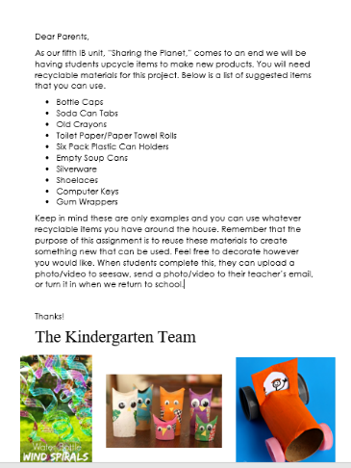 | Complete the “Upcycling Project” using the newsletter found in your email attachments. This project will be ongoing for the entire week.
Additional/Optional | 20 minutes of iRead/20 minutes of iReady Math | 20 minutes of iRead/20 minutes of iReady Math | 20 minutes of iRead/20 minutes of iReady Math | 20 minutes of iRead/20 minutes of iReady Math | 20 minutes of iRead/20 minutes of iReady Math
- Please note that you have different options when turning in assignments. You may turn them in via a picture or video through email, on seesaw, or when you return.
- If you choose to post your completed work on seesaw you will do the following steps.
- Scan the class QR code provided by your teacher (this is different from the parent QR code )
- Once you scan the QR code you may upload your child’s work, there is a youtube link below that you may view to help or use the attachment directions
- The highlighted activities are the ones that will be taken for a grade.

