 | Monday, March 30th | Tuesday, March 31st | Wednesday, April 1st | Thursday, April 2nd | Friday, April 3rd
Math | Addition – Use your finger strategy  Please watch “Use your finger” video.  This will be attached to your email  Sign into SeeSaw using your Classlink login or QR code. Go to the activities tab and find the assignment below.  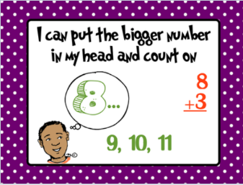 | Addition –Use your finger strategy  Watch: Counting On Video  https://www.youtube.com/watch?v=tLzOkpH2zyM  Sign into SeeSaw using your Classlink login or QR code. Go to the activities tab and find the assignment below.  .  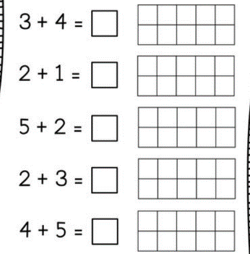 | Addition- Using a Number line Strategy  There will be an attachment in your email with blank number lines for extra practice that you can print out if you choose to do so.  Please watch the “Addition Using a Number Line” instructional video. This will be an attachment in your email.  Sign into SeeSaw using your Classlink login or QR code. Go to the activities tab and find the assignment below.  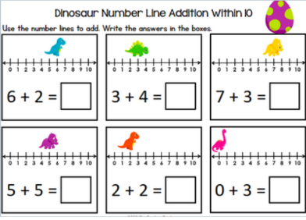 | Addition- Using a Number line strategy  Please watch the “Super ADDler number line strategy” instructional video. This will be an attachment in your email.  Sign into Seesaw using your Classlink login or QR code. Go to the activities tab and find the assignment below  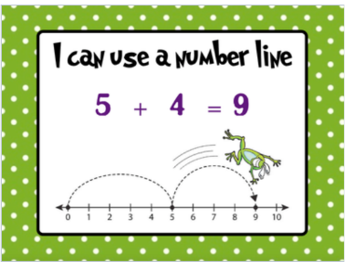 | Choose your favorite addition strategy that you have learned so far and make a video of yourself showing how you use that strategy using an addition equation of your choice and upload it to seesaw.
Reading/Phonics | Reading:  Please watch the “Avid Readers” video lesson in Seesaw and complete the activity.  Login to RAZ kids and choose a book on your reading level. Practice being an avid reader.  What is your favorite thing about being an avid reader from the anchor chart?  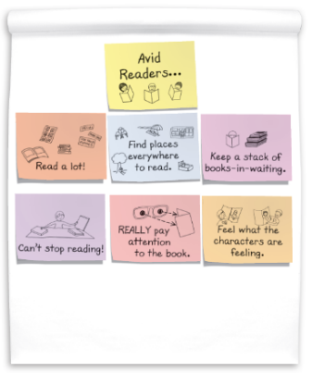  Phonics:  On Seesaw, you will find an assigned activity titled “Ch Digraph Poem”.  Use the highlighter tool to highlight the words that begin with CH, then use the voice tool to read the poem.  On the next page, draw and label a picture of your favorite food that has the ‘ch’ sound.  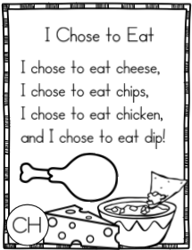 | Reading:  Readers get ready to read by thinking about the text. They do this by:  - Looking at the cover.  - Looking at the pictures.  - Talking about what they see.  They use this information to make predictions about what the book might be about. Login to RAZ kids and choose a book on your reading level. Then, follow the steps above. Read.  Were you correct in your predictions?  What did you have to change in your thinking?  Phonics:  On Seesaw, you will find an activity titled “TH Digraph Poem”  Use the highlighter tool to highlight the words that begin with Th, then use the voice tool to read the poem to your teacher.  On the next page, come up with your own sentence that has a ‘th’ word. Then draw a picture to match your sentence. 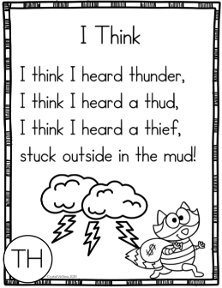 | Reading:  When we read a fiction book, we can identify the characters in the book. Choose a picture book. Read the book or have someone read it to you. Then look at each picture and think, “What might the character be thinking or feeling?”  ▪ Use a post it note or a piece of paper and make a speech bubble.  ▪ Write inside the speech bubble what the character might be thinking or feeling.  Phonics:  On Seesaw, you will find an activity titled “SH Digraph Poem”  Use the highlighter tool to highlight the words that begin with sh, then use the voice tool to read the poem to your teacher.  On the next page, see how many words you can come up with that begin with ‘sh’ and end with ‘sh’.  (ship, shock, shin, wish, fish, cash)  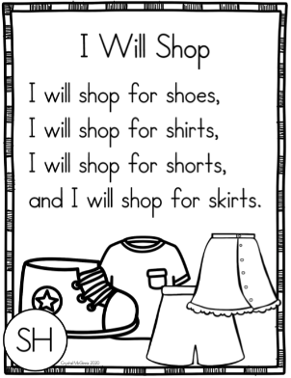 | Reading:  Login to RAZ kids and choose a fiction book on your reading level. Using the “Avid Readers” anchor chart, and practice feeling what the characters are feeling. Draw a picture of a scene from your book.  - How do you think the character or characters are feeling?  - How can you tell?  - What clues does the picture give you to how the character is feeling?  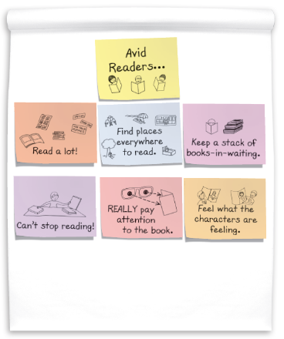  Phonics:  Words with the –ing ending  Watch the video:  https://www.youtube.com/watch?v=hCuggwZ0_ck  On Seesaw, complete the activity “-ing Words”  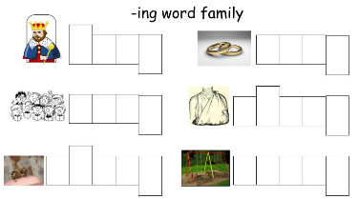 | Reading:  Practice your Sight Words!  Here are some fun ideas to work on your “snap” words!  - Rainbow  - Chalk  - Shaving Cream  - Magnet Letters  Challenge yourself! Try using the words in sentences.  Phonics:  Words with the –ing ending  Watch the video:  https://www.youtube.com/watch?v=E60XlPSDO0o  On Seesaw, complete the activity “-ing Word Sort”  Click and drag the words into the correct column. Then use the voice tool to record yourself reading the ‘ing’ words.  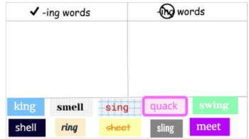
Writing | Watch the “Writing a How-To Make a Change” Video.  Start a How-To Make a change book. Pick an important problem to write about. Give reasons to tell people why they should make a change, and then list the steps for making that change. | Continue working on your “How-To Make a Change Book”. Check your work with the “How-To Writing” anchor chart and the “Making Writing Easy to Read” chart. | We’re finishing up persuasive writing, so it’s time to show what you know. Pick a problem to write about over the next three days.  Some possible problems:  - Cars driving too fast  - People wasting paper  Today, you will make a sign or poster to get people to help solve your problem. | Write a letter to somebody who can help solve your problem. Tell them why they should help you. | Finish your letter from Thursday.
Science | Watch : Parts of the plant video on Brainpop  https://jr.brainpop.com/science/plants/partsofaplant/  Once you watch the video complete the easy quiz. | Go on a nature walk around your neighborhood and search for 2 plants/flowers (you will need 2 for tomorrow.)  Take a picture of one of the plants today and label its parts (roots, stem, leaves, and flower) and put it on seesaw. | Compare the two plants from the previous day.  Talk about how they are the same and different (size, color, shape, numbers of petals etc.)  Take a picture of the plants and record your comparison on seesaw. | Research a flower in your country of study (McKernan-India, Frank- France, Adler-England, Schiavone-China, Makant-Japan, and Kout-Australia)  Once you find the flower take a picture and share facts about it on seesaw . | Continue research from Thursday
Additional/Optional | 20 minutes of iRead/20 minutes of iReady Math | 20 minutes of iRead/20 minutes of iReady Math | 20 minutes of iRead/20 minutes of iReady Math | 20 minutes of iRead/20 minutes of iReady Math | 20 minutes of iRead/20 minutes of iReady Math
- Please note that you have different options when turning in assignments. You may turn them in via a picture or video through email, on seesaw, or when you return.
- If you choose to post your completed work on seesaw you will do the following steps.
- Scan the class QR code provided by your teacher (this is different from the parent QR code )
- Once you scan the QR code you may upload your child’s work, there is a youtube link below that you may view to help or use the attachment directions
- The highlighted activities are the ones that will be taken for a grade.

