McKernan Teleschool Assignments-April 15, 2020

Subject | Lesson | Assignment | Where do I find this?
Math | “Addition Word Problems Strategy” | Video:  Please watch the “Addition word problems” instructional video.  Activity :  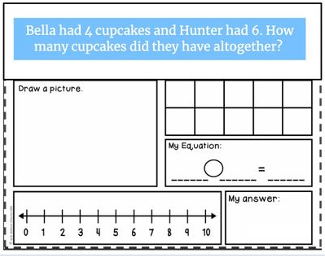 | Video- Email Attachment  Activity : Seesaw
Reading and Phonics | Informational Books | Graded Activity :  Choose an informational book  As your child reads, have them pay attention to the characters (the people or animals), the setting (where the story takes place), and the major events (all the things that happen). Post your child’ response to the book using the questions below  Activity :  - Read, or have someone read to you, a picture book.  - State the name of the book.  - Retell the story-----  - The characters: Who are they? How would you describe them? ----The setting: How would you describe it? The major events: What happened throughout the whole story?  Phonics  Watch the Silent E video on BrainPop Jr. (This can be found on Classlink)  https://jr.brainpop.com/readingandwriting/phonics/silente/  .
Writing | All About Books- Facts | Watch the video on “How Scientists Observe and Learn” Draw and label another picture with the other thing that you found on Monday. When you finish, post it on Seesaw. Remember to observe like a scientist! | Video-Assigned on seesaw
Fun Activity : | Free time | Write words or sentences with shaving cream  Create a creature using playdoe  Retell a story using your stuffed animals  Sing and dance to gonoodle  Journal – Write about how your day is going
Science | Plants | Grow a Bean in Bag Experiment:  Materials Needed:  - A plastic zip top baggie  - One paper towel  - A few beans (any kind)  Directions:  First, fold up the paper towel so that it will fit easily inside the plastic baggie.  Next, wet the paper towel and place at least two beans inside.  Then, put the wet paper towel into the ziploc bag.  Finally, observe for 3-5 days  On a separate sheet of paper, write your prediction of what you will think will happen or what will happen to the bean over time and post prediction to seesaw .  Keep this as a fun ongoing experiment and have your child pretend to be scientist and observe the bean every few days and they may write down their observations
Specials- | Please email the specials teacher, if you have any questions about the assignments they have posted. |  | Mon.-Art rizzoK@fultonschools.org
 |  |  | Wed Music wallaceE1@fultonschools.org
 |  |  | Th/F- P.E. karatassosba@fultonschools.org

