McKernan Teleschool Assignments-April 15, 2020

Subject | Lesson | Assignment | Where do I find this?
Math | “Addition Word Problems Strategy” | Please watch the video “Addition Word Problems Strategy”  Activity Directions :  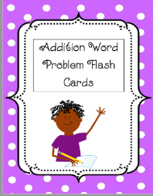  Choose 6 flashcards from the attached packet in your email. For those 6 flashcards, practice circling the numbers and the addition key word and practice writing an addition number sentence. Then, using the last page of the packet, choose one of the 6 flashcards you practiced with to solve the addition number sentence using the different strategies. | Video- Email Attachment  Activity : Email Attachment
Reading and Phonics | Informational Books | Activity:  Work on iread for 20 min  OR  Login Reading A-Z and choose an informational book to read.  Examples- Facts about animals , earth , Legos etc.  Info for parents while their child reads.  While they are reading, have them pay attention to the words that are related to the topic.  ▪ Look at the pictures on the page to see if you can figure out what the word might mean.  ▪ Think about all the words that you are learning about the topic. ▪ Use the words to tell someone all the new information that you learned about the topic.  Phonics  On Seesaw, find the activity titled “Phonics 4/14/2020”. Watch the video and then spell out the Magic E words to match each picture. Record yourself reading the words. | Reading Activity -Reading A-Z  Or iread  Phonics- Seesaw
Writing | All About Books- Facts | Did you know scientists can be writers, too? What scientists write, they start by drawing detailed pictures and labeling important parts to teach others. Draw a detailed picture and add labels to teach about one of the things you found yesterday.  This will be graded | Post picture to seesaw
Fun Activity : | Free time | Choose a fun activity to relax
Science | Plants | Sign into SeeSaw using your Classlink login or QR code. Go to the activities tab and complete the assignment below.  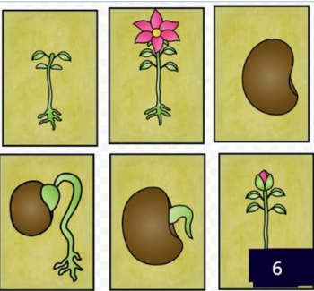 | Seesaw
Specials- | Please email the specials teacher, if you have any questions about the assignments they have posted. |  | Mon.-Art rizzoK@fultonschools.org
 |  |  | Wed Music wallaceE1@fultonschools.org
 |  |  | Th/F- P.E. karatassosba@fultonschools.org

