McKernan Teleschool Assignments-April 13, 2020

Subject | Lesson | Assignment | Where do I find this?
Math | Addtion- key Words | Please watch the “addition key words” instructional video.  Complete Seesaw Activity  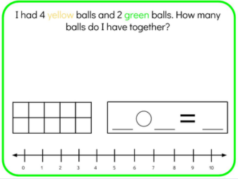 | Email Attachment -Instructional Video  Activity – Seesaw
Reading and Phonics | Fiction Book-  Characters | When we read a fiction book, we can identify the characters in the book.  Choose a Storybook – Examples- “The Billy Goats Gruff, Little Red Riding Hood Etc .  1.Read the book or have someone read it to you.  Activity:  ▪ Identify the characters.  ▪ Draw a picture of the characters in the book.  ▪ Label the characters.  ▪ How you would describe the characters?  Post your picture to Seesaw when finished.  Phonics:  Activity: Seesaw for Magic E.  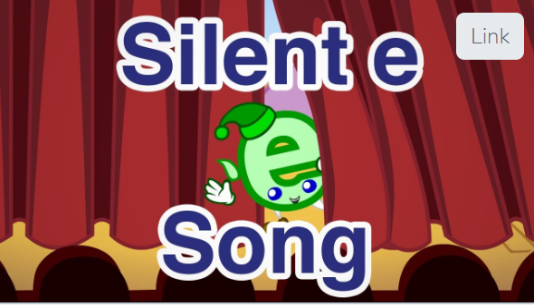  Watch the video and then have your child read the CVC words. They will add the Magic E and then rewrite the new word. Don’t forget to record them reading the new words | Reading:  Post Activity to see seesaw- take a picture and have your child share their picture  Phonics: Seesaw
Writing | All About Books- Facts | We are going to begin a new type of book – All About Books.  Go on a search around your house or outside and look for things you know about.  Activity:  Take a picture of two items and share what you know about the two items you found.  Share why you chose your two items, label your items and post them on Seesaw.  Examples: All about Ladybugs, All about trees, All about Legos, All about strawberries. | Seesaw- Post picture and explain
Fun Activity : | Free time | Choose a fun activity to relax,
Science | Plants | Go onto BrainPop Jr. through Classlink and watch “The Lifecycle of Plants “  https://jr.brainpop.com/science/plants/plantlifecycle/ | Video -BrainPOP
Specials- | Please email the specials teacher, if you have any questions about the assignments they have posted. |  | Mon.-Art rizzoK@fultonschools.org
 |  |  | Wed Music wallaceE1@fultonschools.org
 |  |  | Th/F- P.E. karatassosba@fultonschools.org

