 | Tuesday, March 17th | Wednesday, March 18th | Thursday, March 19th | Friday, March 20th
Math | Shamrock Number Activity  Have students choose a number to represent in different ways. This will be an attachment in your email. See the example below.  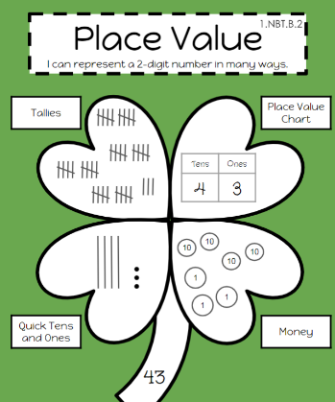 | Counting and Graphing Activity  Have students complete the following activity. This will be an attachment in your email. When finished tallying and graphing, on a separate sheet of paper answer the following questions:  1.Which toy had the most?  2. Which toy had the least?  3 How many toys are there I total?  4. How many more bears are there than balls?  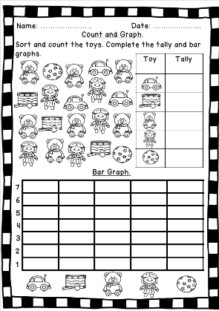 | Measure and Compare - Length  Pick 3 small items around your house (tv remote, crayon, envelope, etc). Find something to use to measure (pennies, paperclips, legos, etc.) and measure each item. Take a picture of how you measured, making sure to follow our measurement rules. Label the longest and shortest item. | SeeSaw: Count, Tally, Graph – Sea Animals:  Sign into SeeSaw using your Classlink login or QR code. Go to the activities tab and find the assignment below.  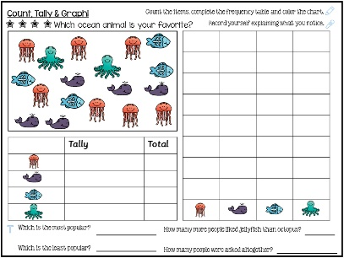
Reading/Phonics | Phonics:  Review Digraph “sh”  Watch the video at the link below: https://www.youtube.com/results?search_query=digraph+sh  Write these sentences:  Shadows shade from the shiny sun.  She has shirts and shoes.  Have students circle the “sh” digraph.  Reading:  Select an informational book. After your second read, answer the following questions:  - What is the main topic of the book?  - Retell the key details of the book to a friend or post to SeeSaw. | Phonics:  Review digraph “th”  Watch the video at the link below: https://www.youtube.com/watch?v=V-cvlZLNEBM  Have your child brainstorm words that have the “th” sound at the beginning (thick, thing, thin, etc.) and at the end (with, fifth, math, path, etc.)  Reading:  Select a fictional book to read. As you read, stop at different parts of the text that make you think extra hard. Use the symbols in the chart to show how you are thinking/feeling in those parts of the book. Then share your thinking/feeling with a friend or family or post to SeeSaw. | Phonics:  Review Digraph “ch”  Watch the video at the link below: https://www.youtube.com/watch?v=8JmCrl4FHj8  Say these words and have students write them on paper or whiteboard:  Chop, chip, chat, chin, chap, chant, champ, chug  Reading:  Select a book from your home or library to read with a partner. Choose different ways to read the book together with your partner located on the anchor chart.  - What ways of reading did you try with your partner?  - What was your least favorite way to partner read?  - What was your favorite way to partner read? Why?  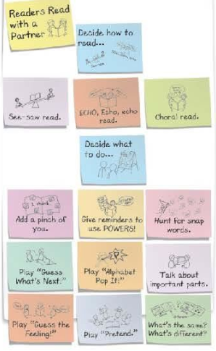 | Phonics:  Review all digraphs : th, sh, ch  Say these words and have students write them:  Thin, chip, shop, shin, chat, fish, wish, with, ship,  Reading:  Practice your Sight Words!  Here are some fun ideas to work on your “snap” words!  - Rainbow  - Chalk  - Shaving Cream  - Magnet Letters  Challenge yourself! Try using the words in sentences.
Writing | How to Catch A Leprechaun  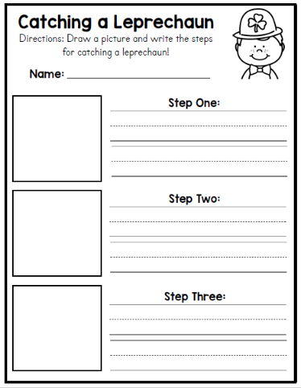  List all the steps you would need to catch your leprechaun! This will be an attachment in your email.  Don’t forget to use transition words for each step: first, to begin, after that, next, then, last, finally, the end, etc. | In your opinion, which special is the best?  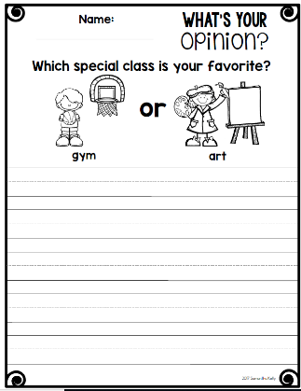  Fill out the sheet that can be found in an attachment via email. Don’t forget to begin your writing with ,”In my opinion,” “I think,” or “I believe,” and give at least 3 reasons supporting your opinion. Please see the sample anchor chart to help you. |  | Continue your persuasive piece from Thursday.
Science | Through Classlink, open the BrainPopJr. App.  Search for “Arctic Habitats” and watch the video. After the video, choose an artic animal to write about.  -What does it look like?  -What does it eat?  -How does it survive in its habitat? | Through ClassLink, open the MackinVia App.  Use MackinVia to research polar bears. Use the worksheet attachment in today’s email to complete this research assignment.  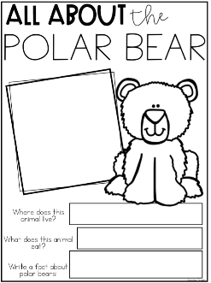 | Through Classlink, open the BrainPopJr. App.  Search for “Desert” and watch the video.  After the video, make a list of animals you might find in this habitat. | Through ClassLink, open the MackinVia App.  Use MackinVia to research rattlesnakes. Use the worksheet attachment in today’s email to complete this research assignment.  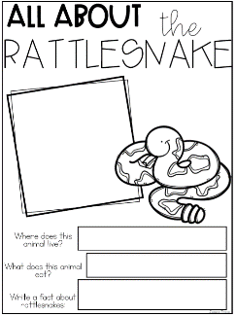
Additional/Optional | 20 minutes of iRead/20 minutes of iReady Math | 20 minutes of iRead/20 minutes of iReady Math | 20 minutes of iRead/20 minutes of iReady Math | 20 minutes of iRead/20 minutes of iReady Math
- Please note that you have different options when turning in assignments. You may turn them in via a picture or video through email, on seesaw, or when you return.
- If you choose to post your completed work on seesaw you will do the following steps.
- Scan the class QR code provided by your teacher (this is different from the parent QR code )
- Once you scan the QR code you may upload your child’s work, there is a youtube link below that you may view to help or use the attachment directions
- The highlighted activities are the ones that will be taken for a grade.

